**Name of Student: Ramit Bose**

**Reg.No.: 21BCE1316**

**Ex. No:10**

**Date :10-04-2023**

**Title:  Story Boarding and UI Design Modelling**

**Aim:**

JIRA – BASED STORY BOARDING FOR YATM Management System

**Procedure:**

1. Go to JIRA website
2. Register with your official id
3. It will ask you to give a name for your website – give name
4. Then it will ask some basic introductory details as below:

**create Back log with the User Stories as below:**

Define all the functions/features required in developing the software under Backlog.

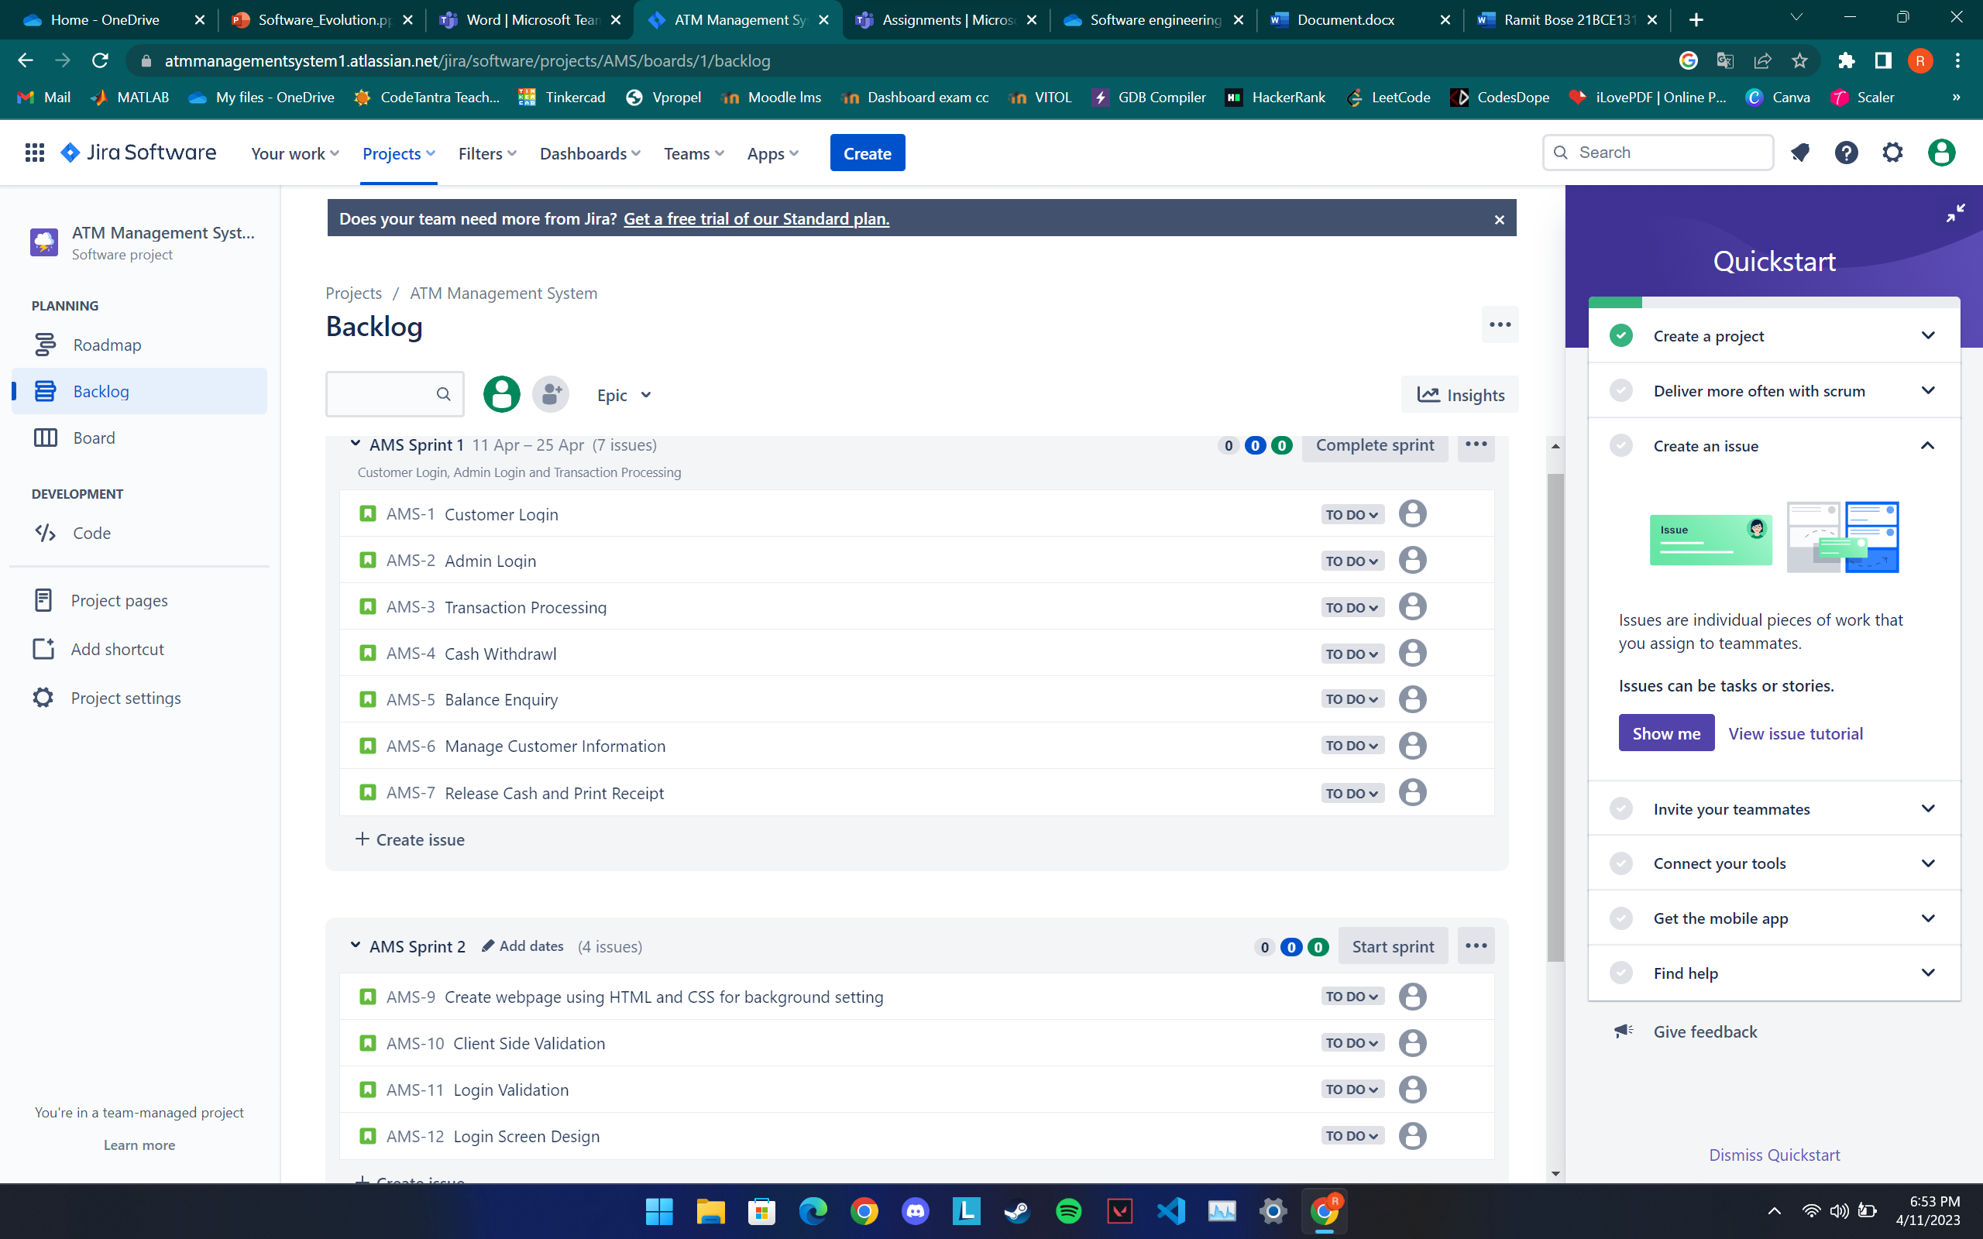

**Once finalized the features entry in Backlog, Start the Sprint as below:**

**Now, you click the link on the left pane – Board**

**It will show you the User stories in the board with their current status**

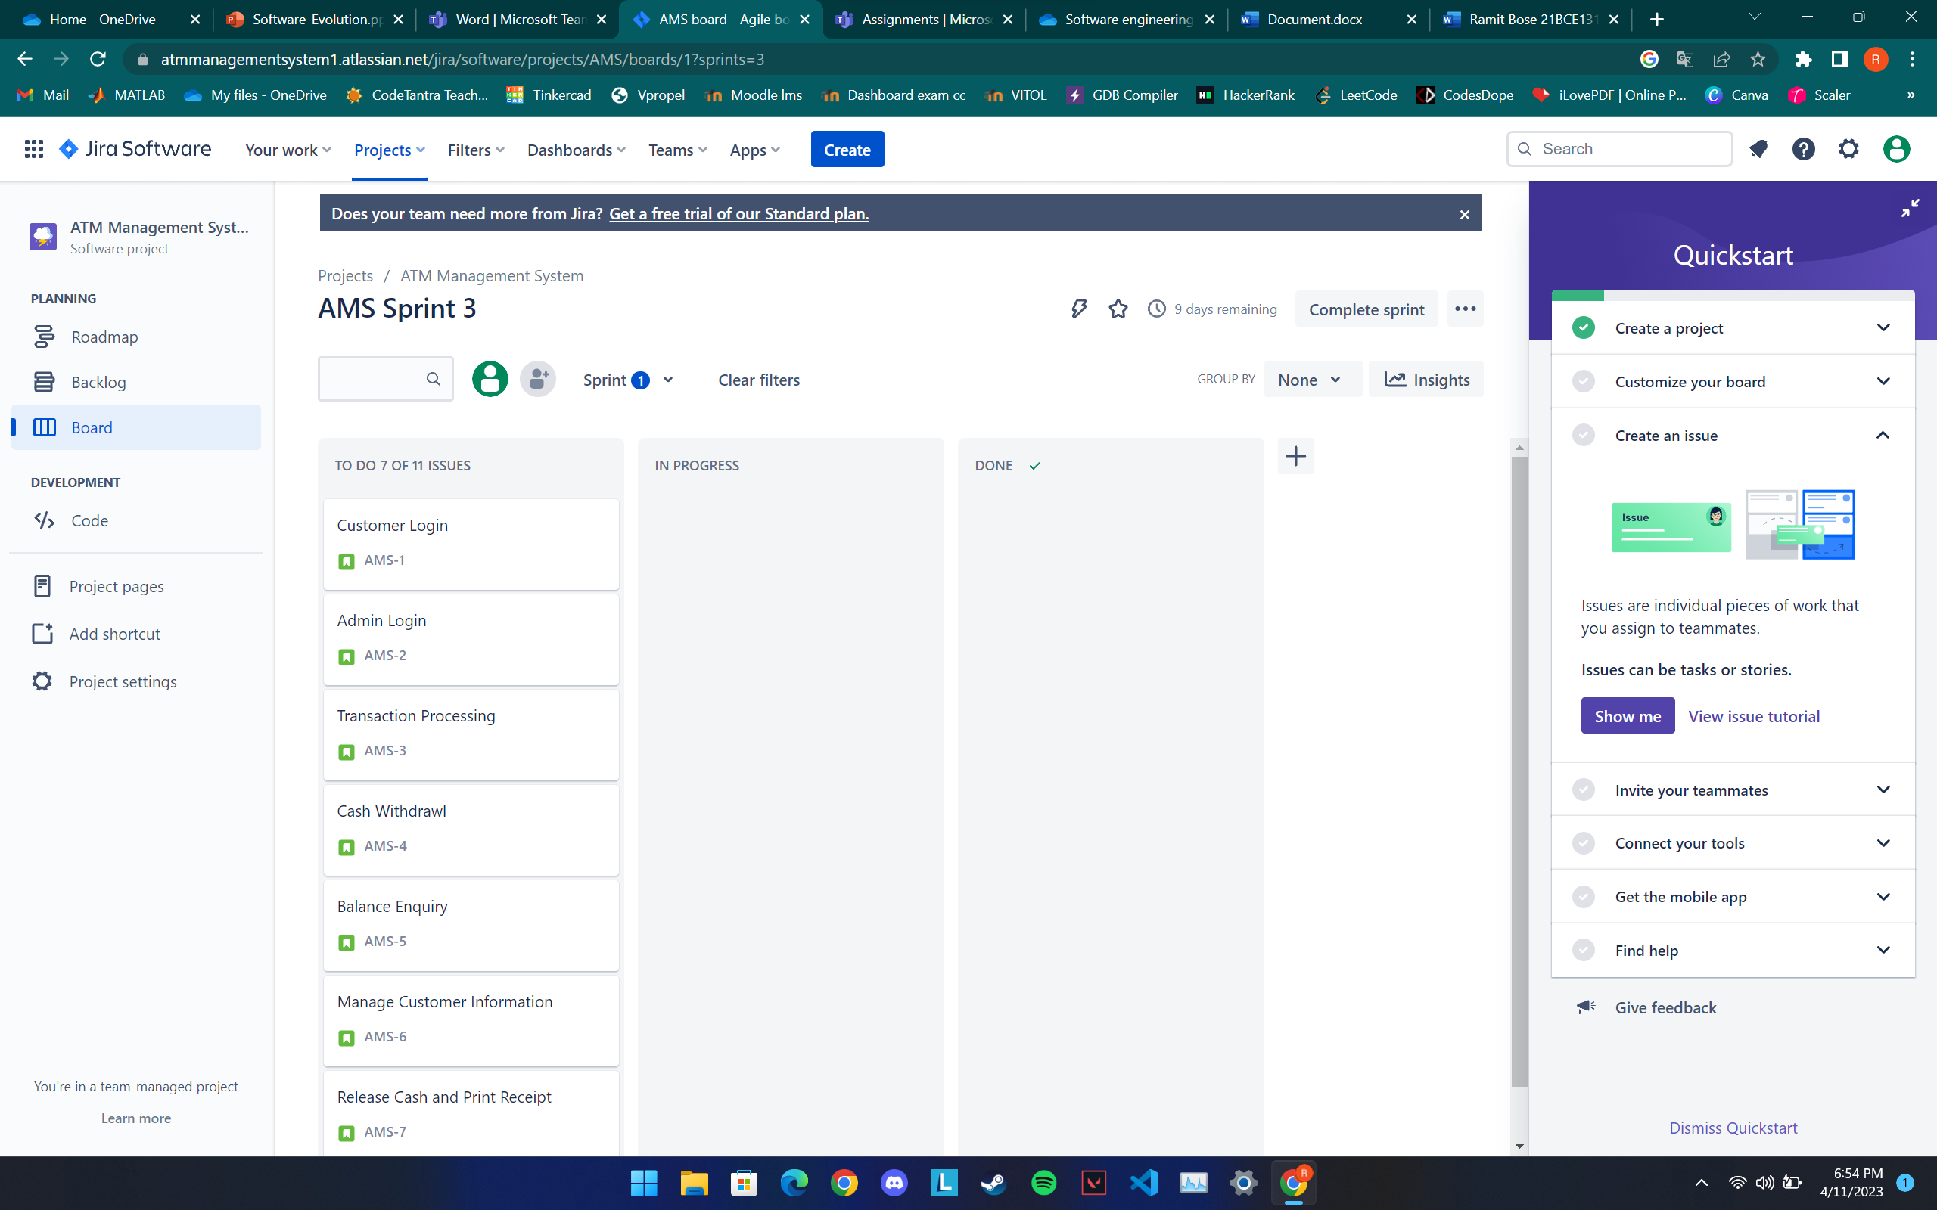

**You can change the stories current status to In Progress or Done as below**

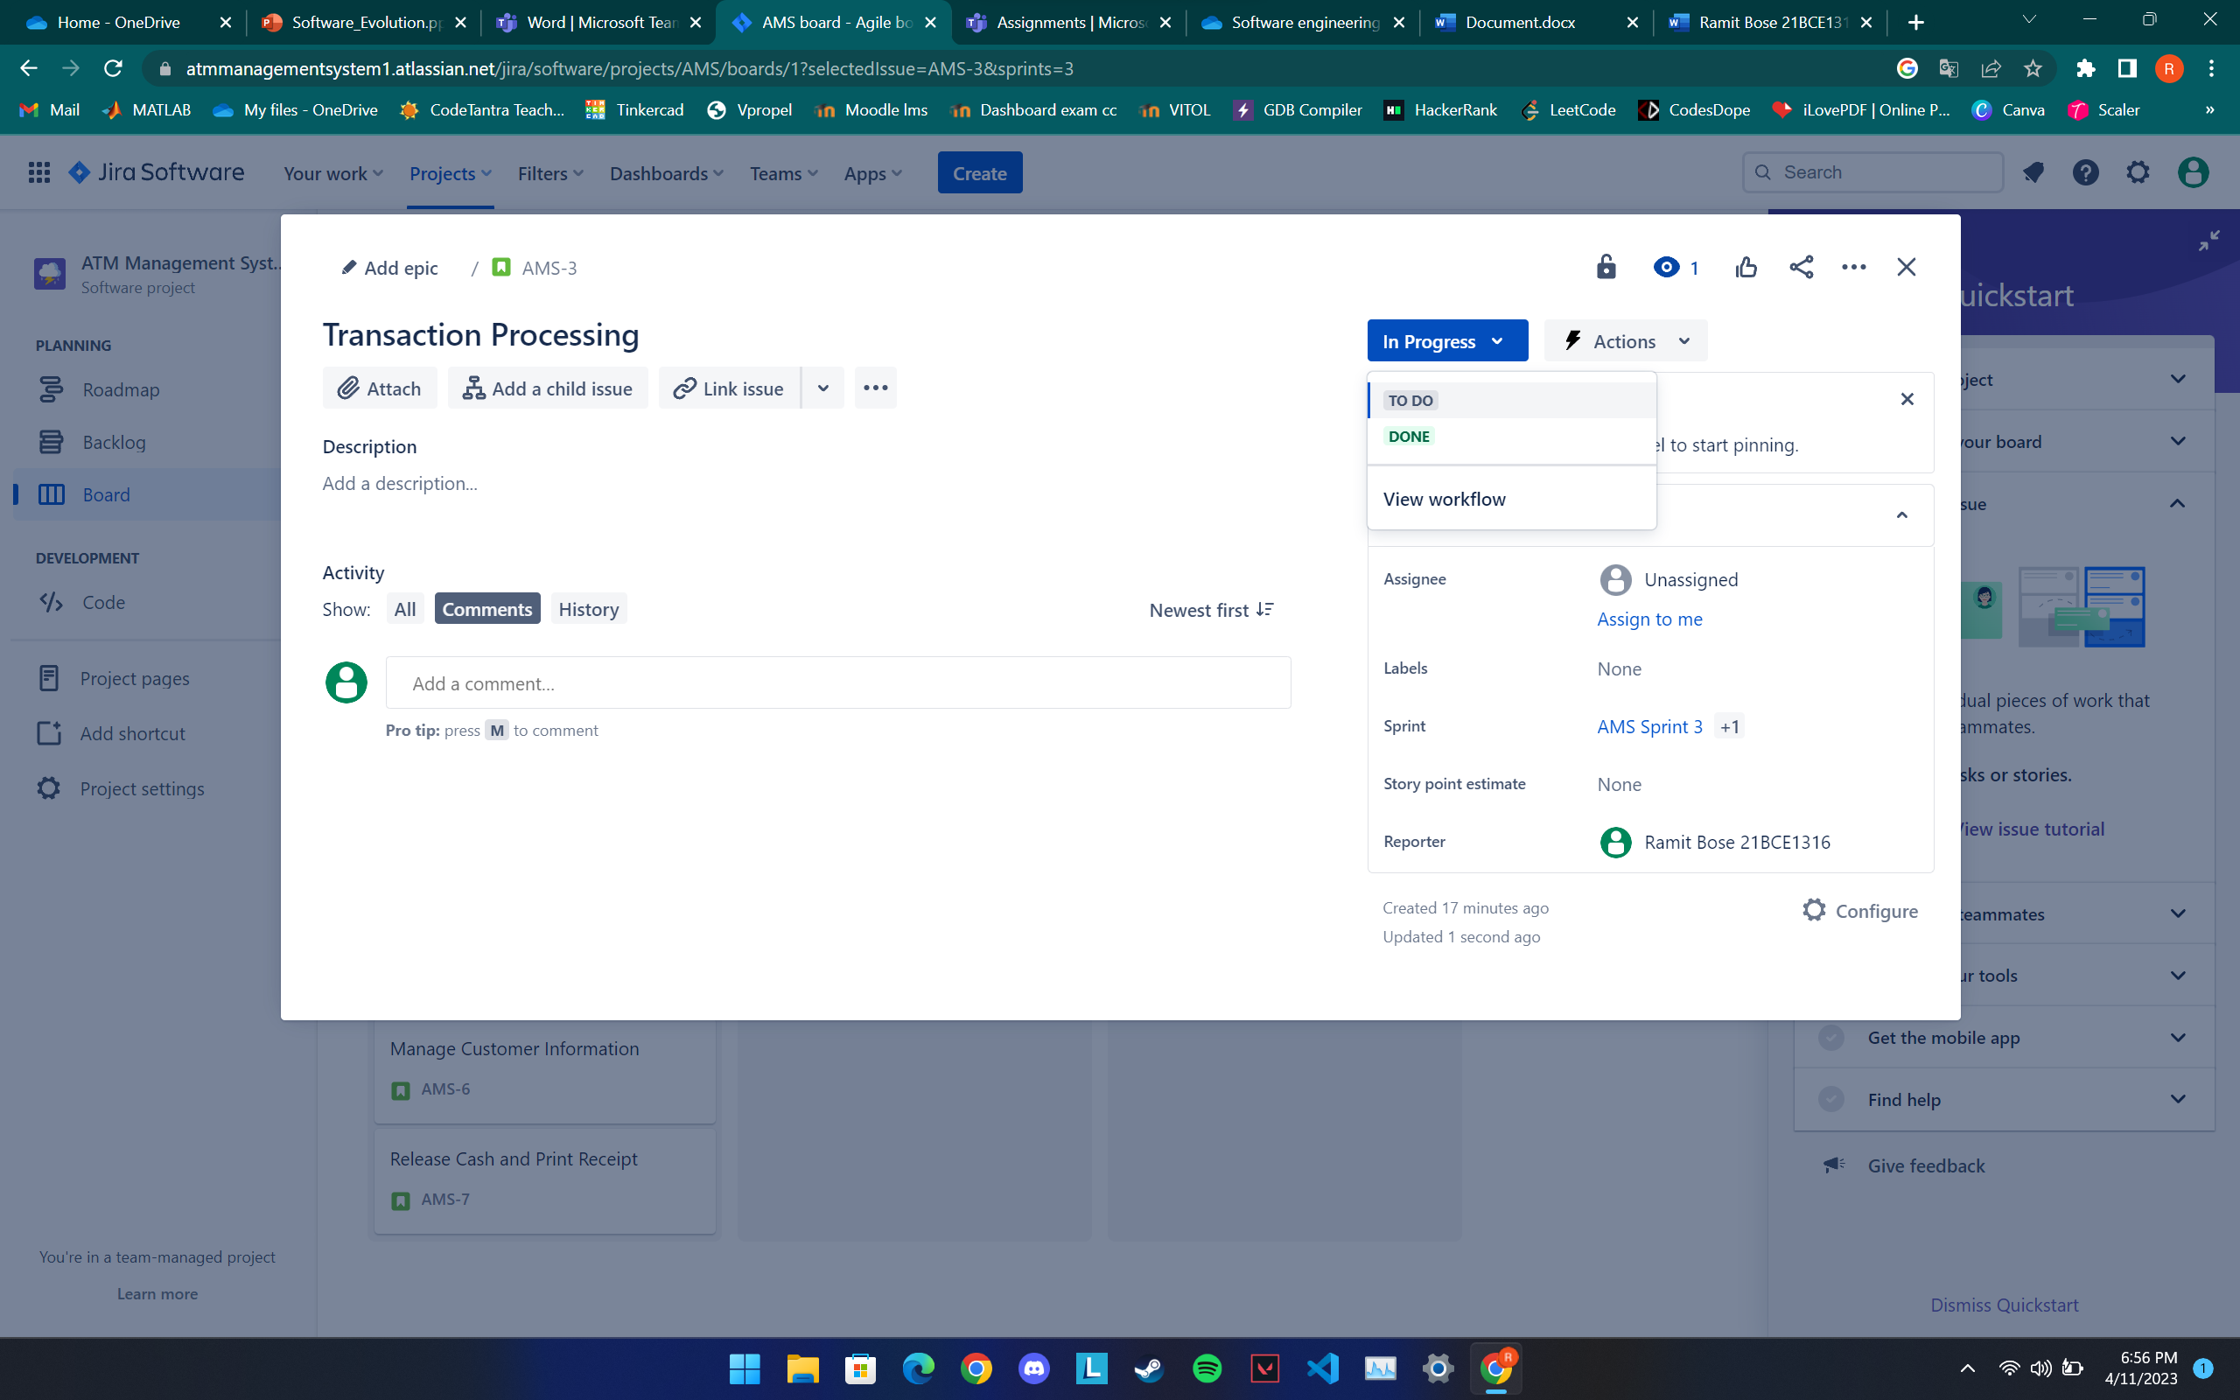

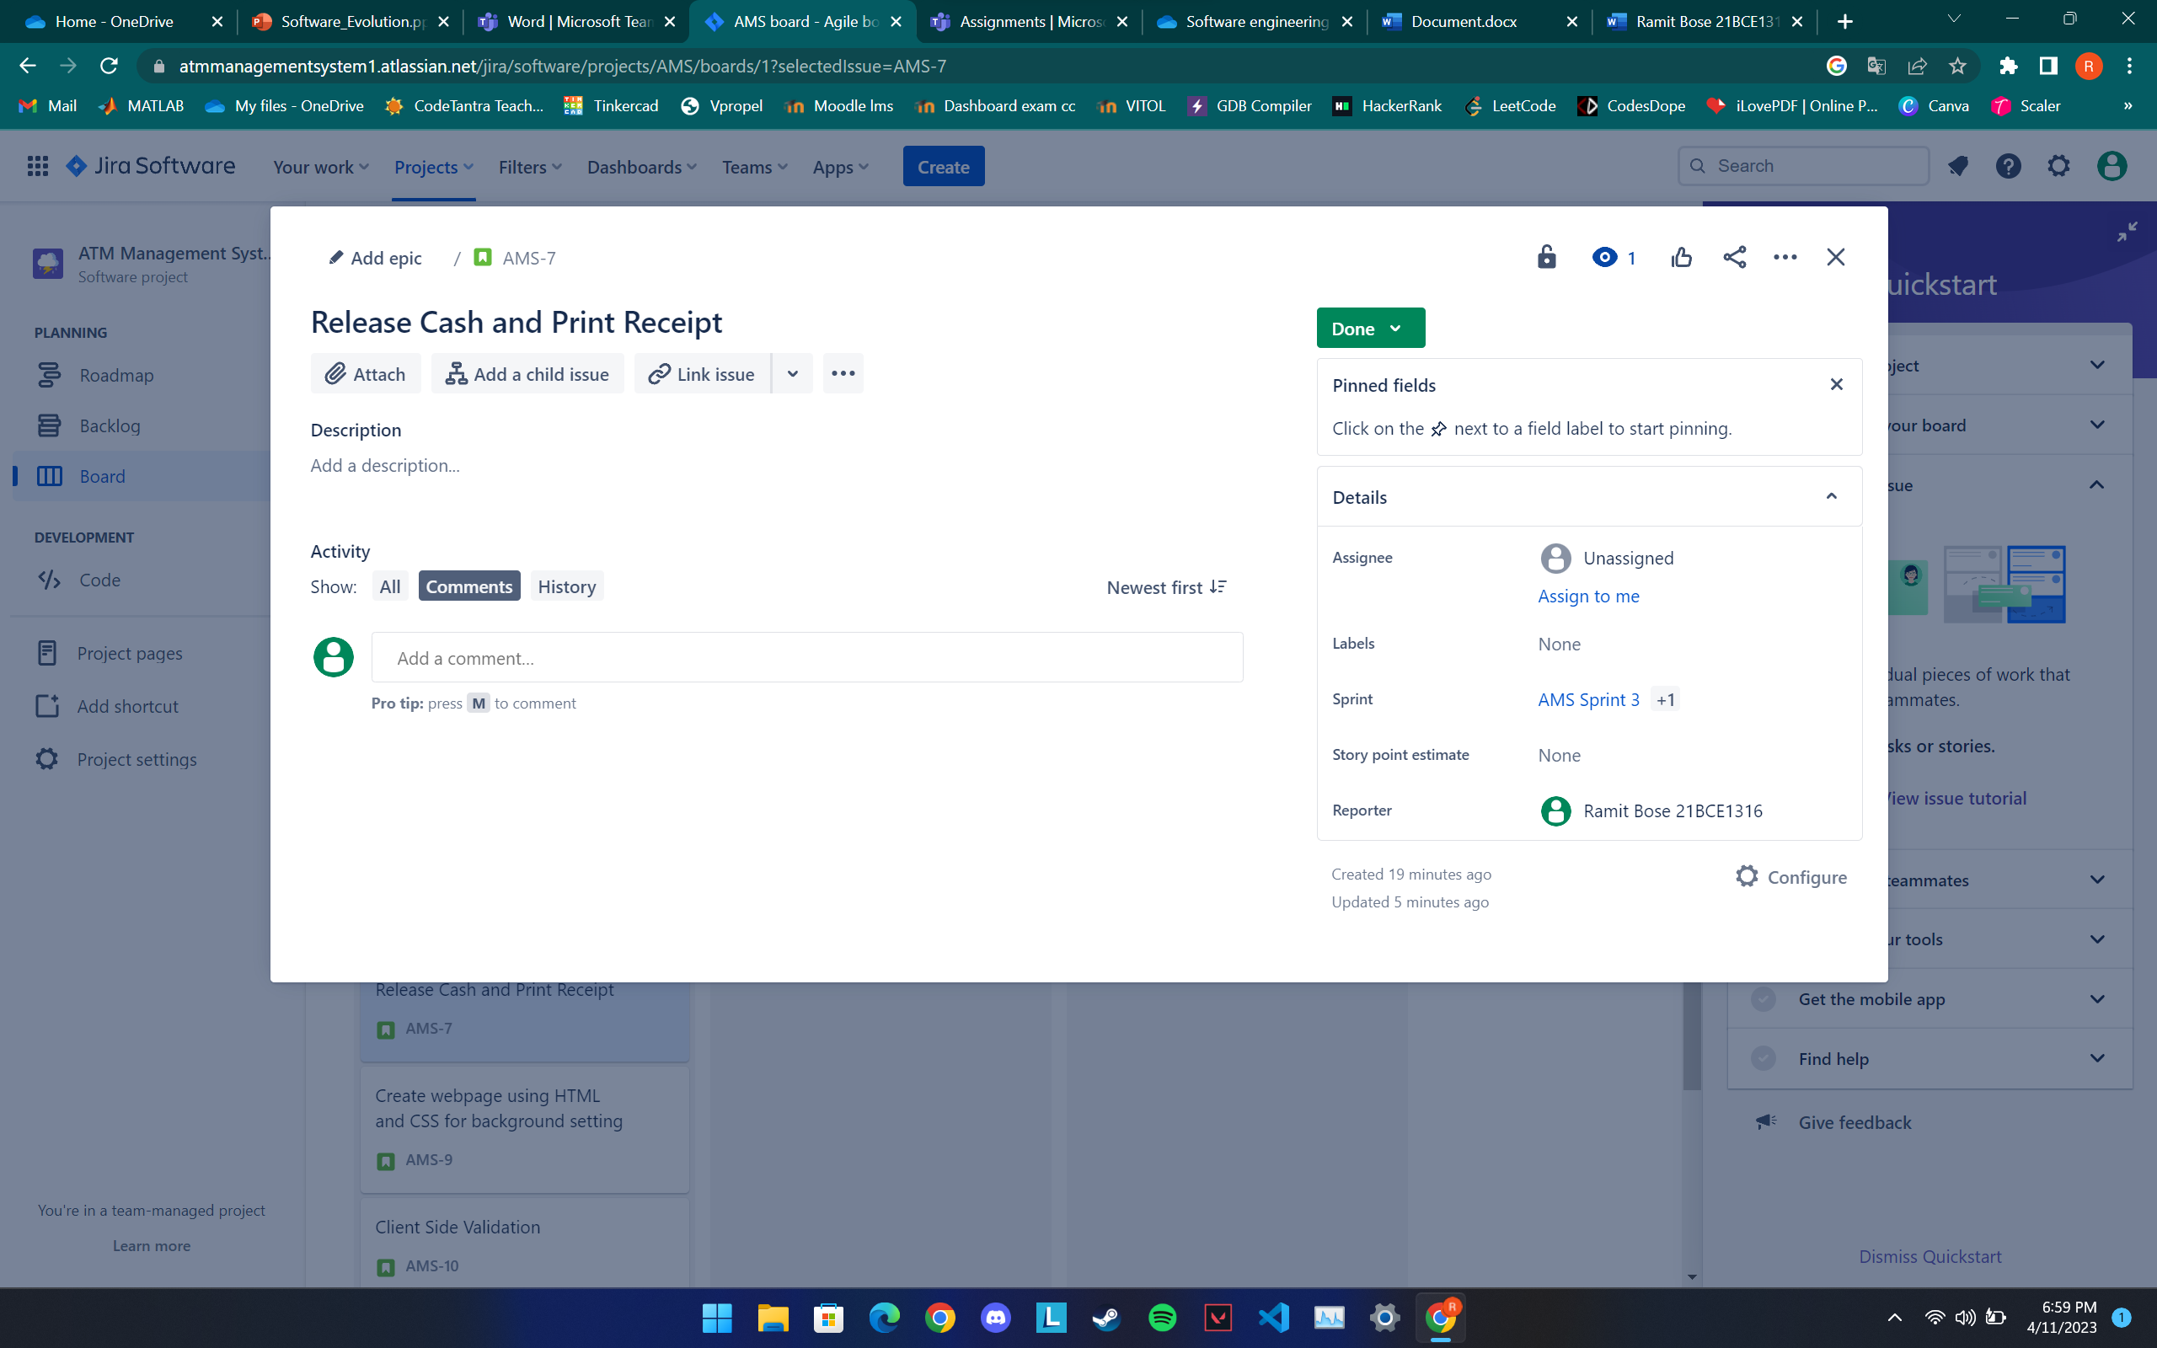

**If you have completed the status change, check for the update by clicking again the –Board Link in the left pane.**

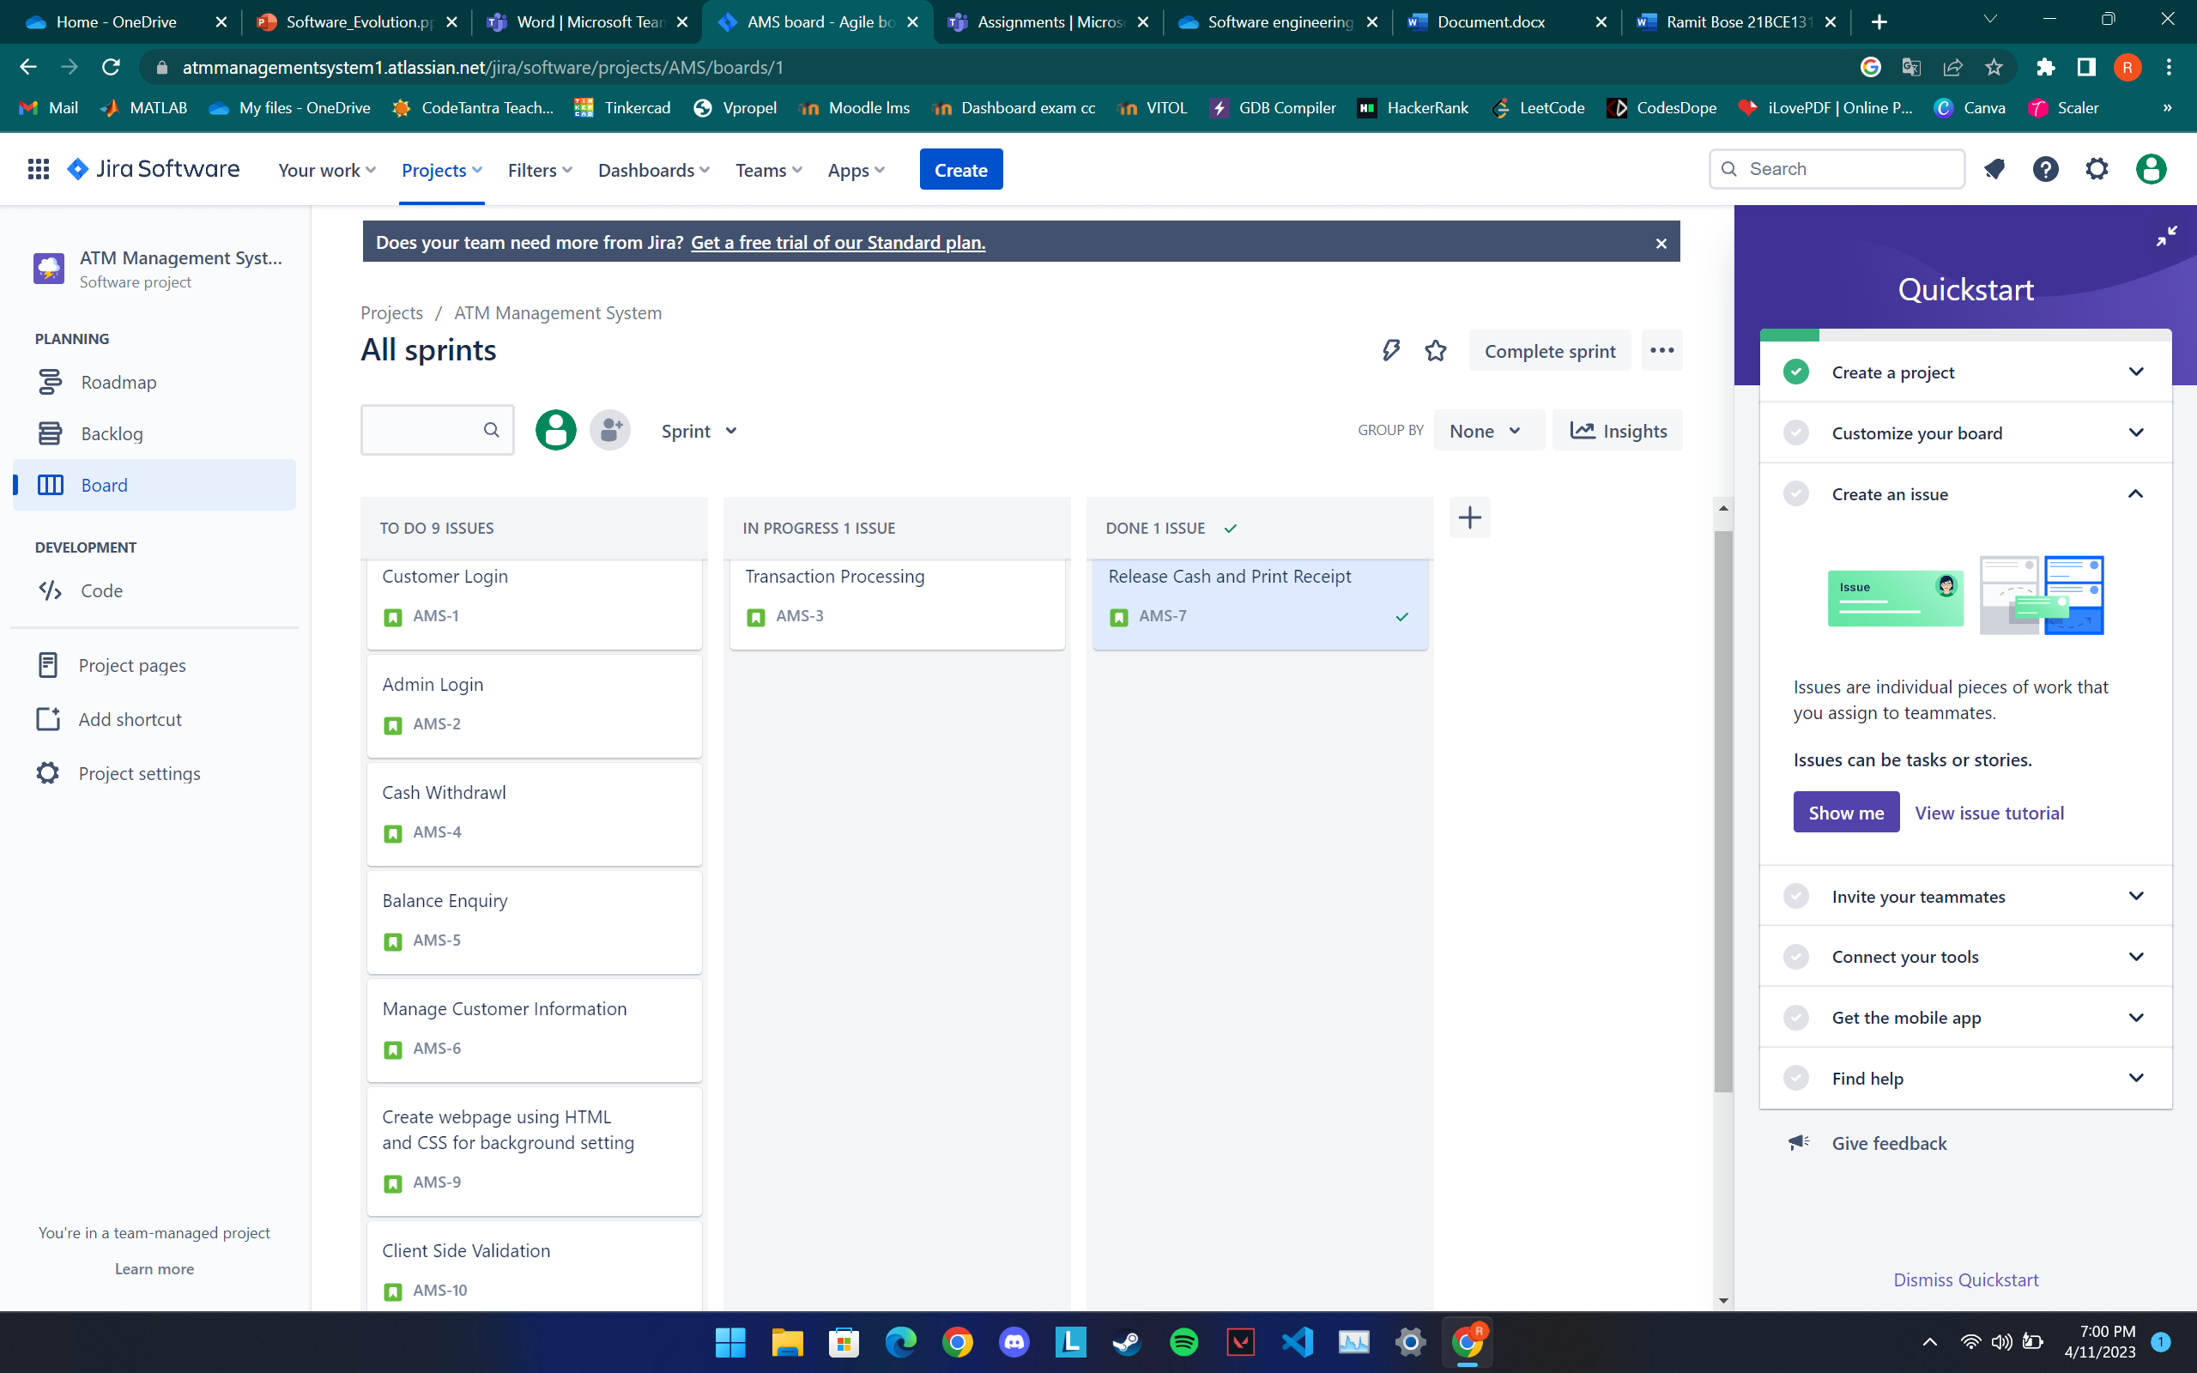

**RESULT**

Once all these are over, the complete story boarding is done.